France entering full steam ahead into a Secondary Depression
SECONDARY DEPRESSION: A refresher on XIX century, beginning of XX century cyclical analysis
- First came the boom, and the leverage associated with it. The financial genius in this phase was the fellow who borrowed massively to buy assets and had no memory .
- Second , we had the "panic" when the market participants realize that the return on invested capital was falling below the cost of capital. This phase, normally was very brief, a few months at most, and usually associated with collapsing stock markets and asset prices and quite a few bankruptcies in the financial system.
- At the end of this phase, interest rates went down massively, and on this decline on interest rates the market participants thought was the crisis was over and we had a massive 'relief" rally
- And then came the "secondary depression", created by a very simple fact: the ROIC on investments stayed BELOW the very low cost of capital. Usually the secondary depression lasted three to five years and it was during that time that most of the money was lost.
Why am I talking about that very old notion: simply because the internal mechanisms of the Euro are very similar with those of the Gold Exchange Standard, and that the same causes tend to produce the same effects.
For example, as I have been arguing for quite a while, Italy and Spain have been in a secondary depression for some time and I see no sign whatsoever of them getting out of it. (They cannot devalue)
Some time ago, I said that France was also about to enter a secondary depression. The policies followed by the French government have been bad enough to make that probability a certainty and the data being published in France are coming in so fast and furious that there can be no doubt left.
Indeed, I have now all the signs that I need to announce that the French economy has joined the Spanish and Italian economies in their secondary depressions
I will first present the evidence, and then move on to the investment consequences.
The Evidence
As I did for Germany, where I based my analysis of the German economy on the IFO survey, I will use the INSEE survey for the French economy.
This survey is published monthly and has a long and reliable history, the lead time between the survey and different economic variables varying between three to nine months

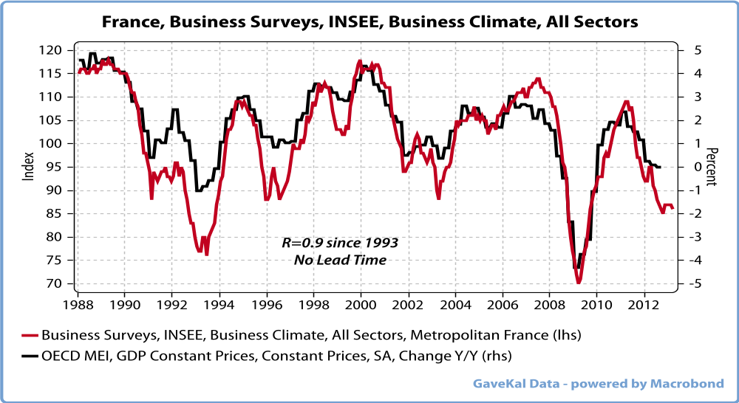
If I do a regression between the survey and the French GDP, i find that the French GDP will be down y/o/y by around 1 % in six months time or so.
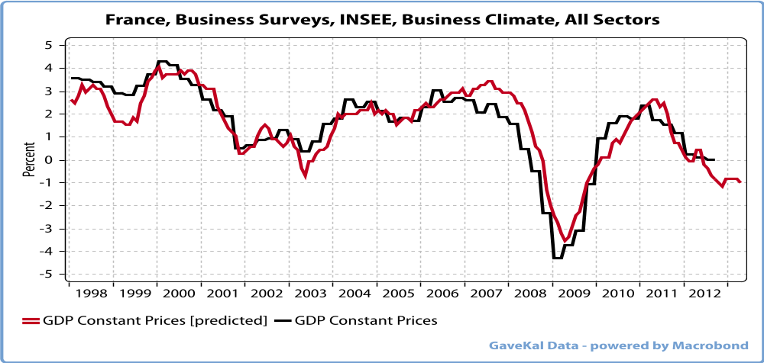
Since 57 % of the French GDP is government related, one should not expect that part of the GDP to come down at all.
So all the decline should take place in the private sector GDP, and this implies cratering of a t least 3 % of the private sector GDP, as evidenced by the next graph
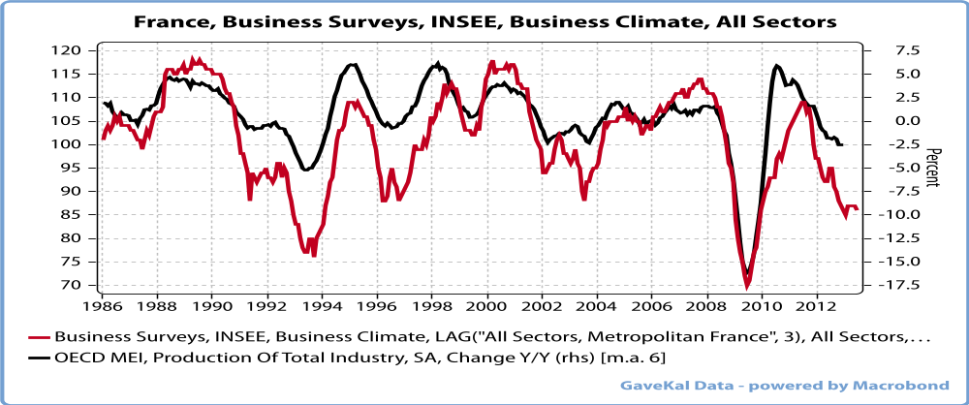
As the reader may remember, I am always using industrial production as a proxy for what is happening in the PRIVATE SECTOR part of the economy, and the results look ominous, to say the least. ...
As a result of this collapse, employment is of course going to implode.
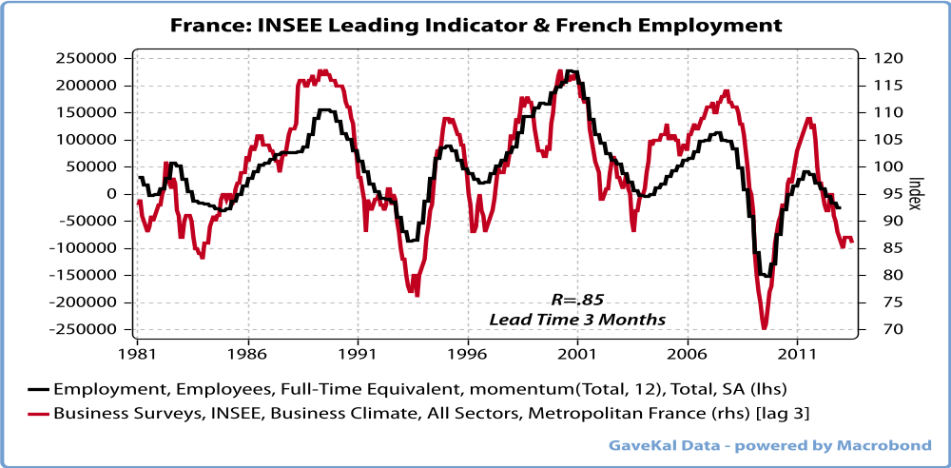
And with French Employment collapsing, it is to be feared that French consumption will too
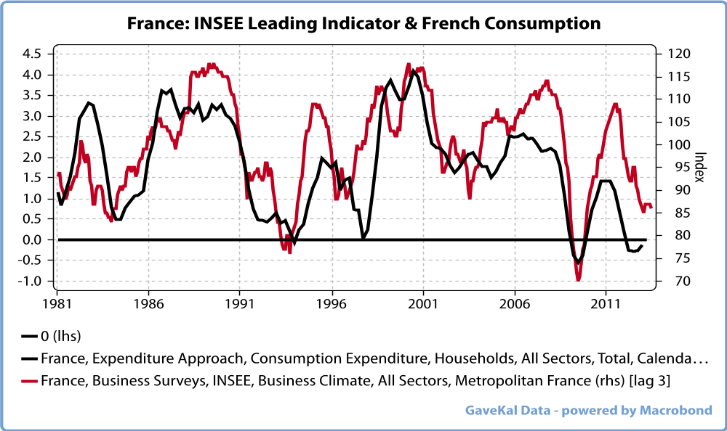
I rest my case. France is in a secondary depression.
The time has come to move to the Investment consequences...
Investment Consequences.
- A divergence between France and Germany is starting to appear for the first time which will lead to a dramatic increase in the tensions in the Euro system.
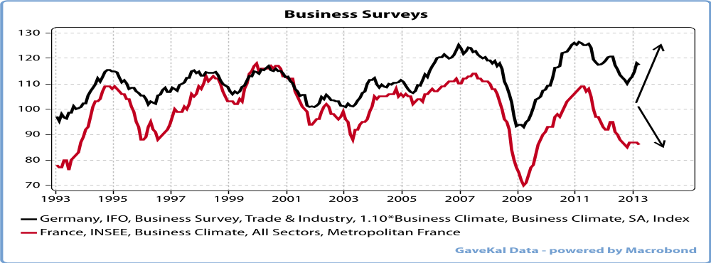
- French Imports are going to collapse, which will make the situation in Spain, Italy and even Germany much more difficult that everybody is expecting today, since France is the first or second client for most of these countries.
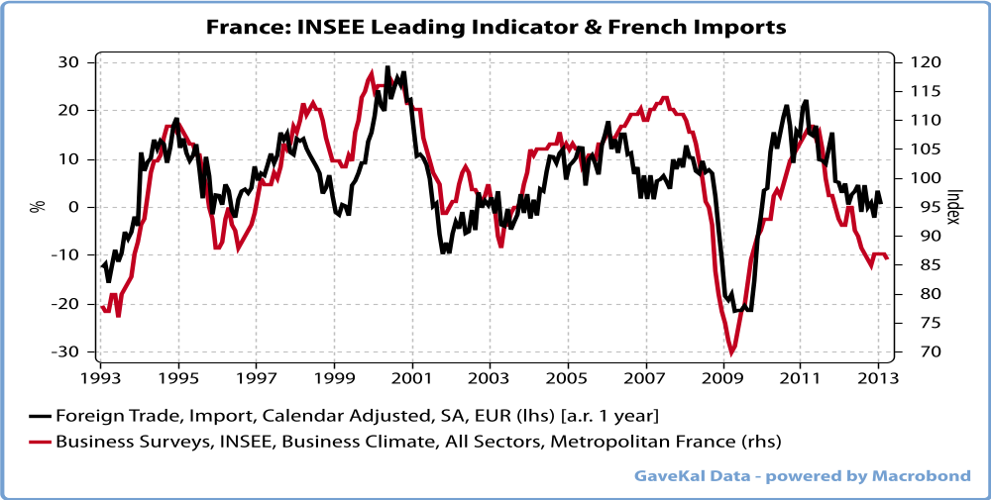
- The French Budget deficit is going to explode upwards. Less employment= more expenditures. Less consumption= lower VAT. Lower economic activity= lower tax receipts.
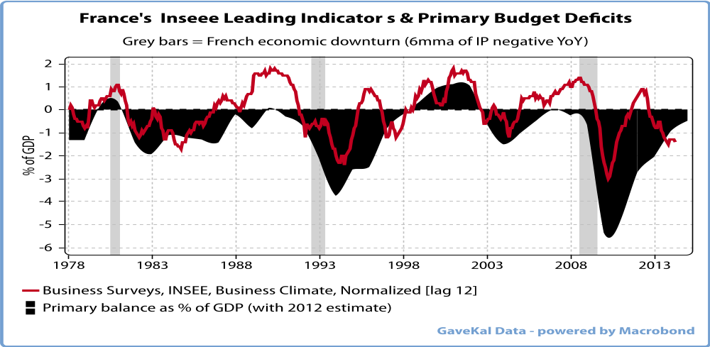
As a result, the primary budget deficit will deteriorate massively in 2013, again as it did in every previous case when we had our leading indicator falling. This could lead to tensions on the French US long rates, have we have seen in the past in Italy or Spain, for similar reasons and this will make the budget situation unmanageable almost immediately.
- Corporate profits will go down, at least for the part linked to the French or Southern European economies.
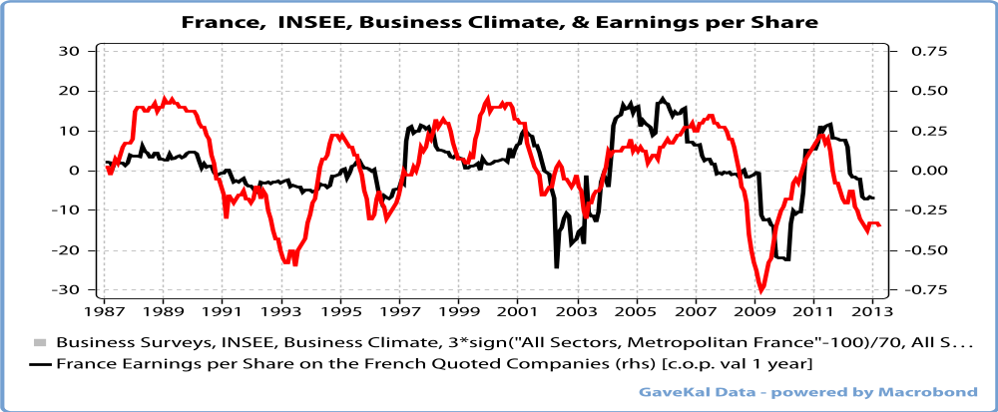
Conclusion
France is entering into a secondary depression.
But France is a very, very special animal.
While in Spain or in Ireland the excesses took place in the real estate sector, in France the excesses took place in the Public sector. (Remember, too many houses in Spain, too many factories in Germany, too many civil servants in France)
The ever declining interest rates were used by the Public Sector, which totally control the POLITICAL SYSTEM, to hire more and more people in order to increase their votes at the time of the elections (This is what I called social Clientelism).
As a result, France is the ONLY country among those we follow where never ONCE since 1987 the growth of the private sector was higher than the growth of the public sector, as evidenced by the graph below.
For the last 25 years, EVERY YEAR, the French public sector has grown faster than the private sector.
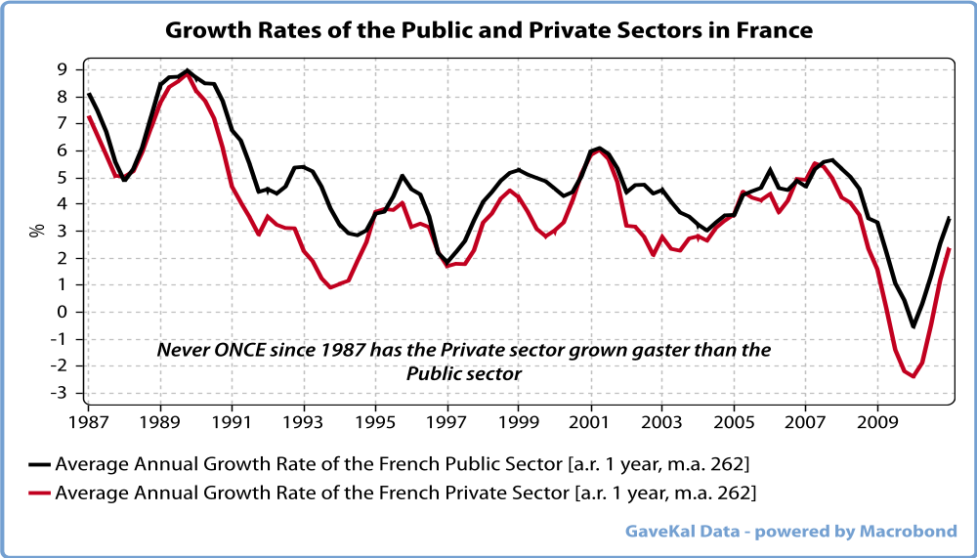
This is of course implies that the size of the government as a % of the GDP has gone through the roof in the last 25 years, and it has...and it made absolutely NO difference if the so called right or if the left was in power, none whatsoever.
Today, the administrative sector represents 57 % of the French GDP, the highest in the world barred Denmark.
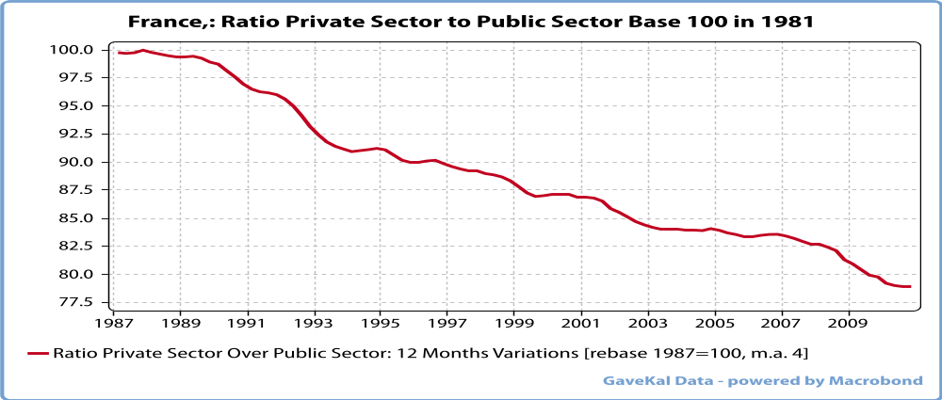
So what has to be understood for France is that the real problem is simple: the fellows managing the economy have organized a system whereby the public sector quietly , year after year, pillage the private sector, with the blessing of the population
And this constant stealing has led to lower and lower corporate profits and from there to lower and lower economic growth, and to higher and higher unemployment.
What has to be understood is that the French problem is a MORAL problem.
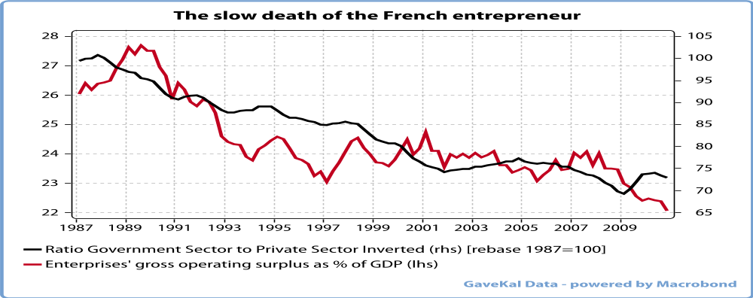
In fact, the situation in France is far worse than anywhere else in EuroLand simply because the fellows in charge are not only enemies of the private sector but that they also believe that it is MORAL to steal money from the entrepreneurs to give it to the civil servants.
The French problems thus come from the fact that the population has been taught that it was moral to steal, and that one cannot build growth on such a belief. (See the ten commandments)
In fact the elites in France are all convinced of the moral superiority of a communist technocracy over capitalism, and so does now a large part of the population.
So the solution for France is NOT some technical changes, but a revolution which would bring to power some sensible people with a different set of values.
The problem is that the French have just voted for more pillaging and more communist technocracy, and that the current government has passed the overdrive to oblige them.
The music will stop whenever the foreigners will stop lending which will happen when the last French entrepreneur will get out of France and will close the lights before he leaves.
Given the coming secondary depression, which will hit the ability of the State to continue stealing, it could happen at any time.
My original idea was for the French debt crisis to occur between 2014 and 2017, but given the extraordinary malfeasance of the current government it could happen earlier.
Fasten your seat belt in Europe.
The last communist country in the world is about to implode.

